Gitlab:- repo for smoke test CA automation is configured with CI/CD pipeline

Repo name :- **cmpl_auto_test_automation**

We have four files under :- **cmpl_auto_test_automation**

1. Devops_script 🡪 here we will write test scripts ( i.e. code in my case env JSON and collection JSON files), [dependencies.sh](https://source.tui/customer/customer-services/case-management/complaints-automation/ca_test_automation/cmpl_auto_test_automation/-/blob/main/devops_scripts/dependencies.sh?ref_type=heads) (to download if and scripts. Yml ( here we give instruction to install Newman and run the collection and env JSON file



1. [.gitlab-ci-iam.yml](https://source.tui/customer/customer-services/case-management/complaints-automation/ca_test_automation/cmpl_auto_test_automation/-/blob/main/.gitlab-ci-iam.yml?ref_type=heads)
2. [.gitlab-ci.yml](https://source.tui/customer/customer-services/case-management/complaints-automation/ca_test_automation/cmpl_auto_test_automation/-/blob/main/.gitlab-ci.yml?ref_type=heads) 🡪
3. [README.md](https://source.tui/customer/customer-services/case-management/complaints-automation/ca_test_automation/cmpl_auto_test_automation/-/blob/main/README.md?ref_type=heads) 🡪 this is just a sample file

[devops_scripts](https://source.tui/customer/customer-services/case-management/complaints-automation/ca_test_automation/cmpl_auto_test_automation/-/tree/main/devops_scripts?ref_type=heads)

- [devops_scripts](https://source.tui/customer/customer-services/case-management/complaints-automation/ca_test_automation/cmpl_auto_test_automation/-/tree/main/devops_scripts?ref_type=heads) > Test_scripts

[devops_scripts](https://source.tui/customer/customer-services/case-management/complaints-automation/ca_test_automation/cmpl_auto_test_automation/-/tree/main/devops_scripts?ref_type=heads) >dependencies.sh

[devops_scripts](https://source.tui/customer/customer-services/case-management/complaints-automation/ca_test_automation/cmpl_auto_test_automation/-/tree/main/devops_scripts?ref_type=heads) >scripts.yml

- newman run Demo_neuman.postman_collection.json -e CA_Environment.postman_environment.json -r htmlextra --reporter-htmlextra-export index.html || true

- newman run Demo_Smoke_Test.postman_collection.json -e CA_Environment.postman_environment.json -r htmlextra --reporter-htmlextra-export index.html || true

[.gitlab-ci-iam.yml](https://source.tui/customer/customer-services/case-management/complaints-automation/ca_test_automation/cmpl_auto_test_automation/-/blob/main/.gitlab-ci-iam.yml?ref_type=heads)

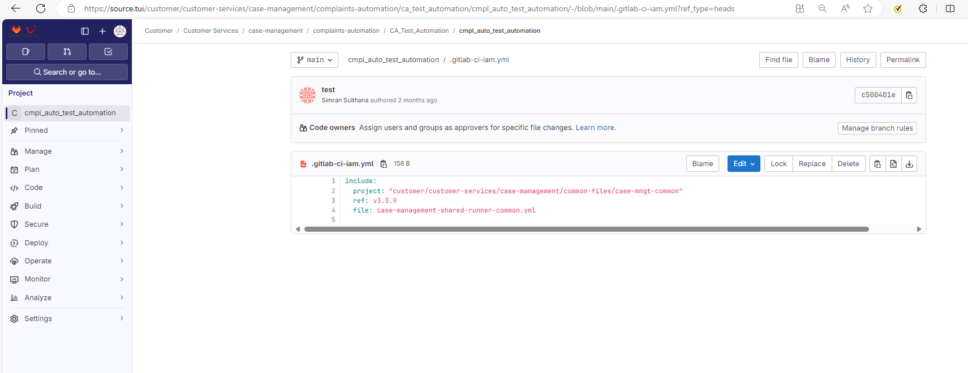

[.gitlab-ci.yml](https://source.tui/customer/customer-services/case-management/complaints-automation/ca_test_automation/cmpl_auto_test_automation/-/blob/main/.gitlab-ci.yml?ref_type=heads) 🡪

